DB-C4-S3-THEORY VIEW

This exercise is based on given ONLINE database:

<https://www.w3schools.com/sql/trysql.asp?filename=trysql_select_where>

* Test your queries on the online editor
* Copy / paste your answer for each question on this document

**Q1:** Write a query to create a view for all customers who are coming from France.

CREATE VIEW [Form France] AS SELECT CustomerName FROM Customers WHERE Country="France";

**Q2:** Write a query to create a view of order quantity more than 50.

CREATE VIEW [quantity more 50] AS SELECT CustomerID FROM Orders WHERE CustomerID >50 ;

**Q3**: Write a query to create a view of products with a price between $10 and $30.

CREATE VIEW [quantity] AS SELECT Price FROM Products WHERE Price BETWEEN 10 AND 30;

**Q4**: Write a query to create a view of suppliers coming from Japan and only from Tokyo city.

CREATE VIEW [Japan Contry] SELECT Country FROM Suppliers WHERE City= "Tokyo";

**Q5:** Write a query to create a view to display product name in each category without any duplicate.

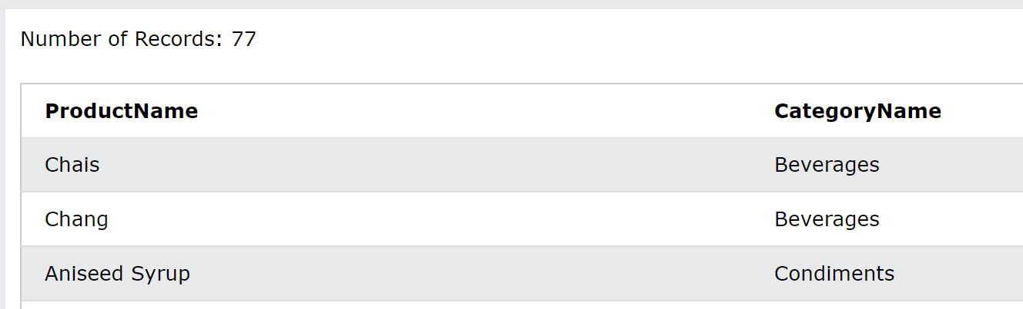

CREATE VIEW [ProductName and CategoryName] AS SELECT Products.ProductName, Categories.CategoryName FROM Products JOIN Categories ON Products.CategoryID = Categories.CategoryID;

**Q6:** Write a query to create a view to display all customers and employees as seller

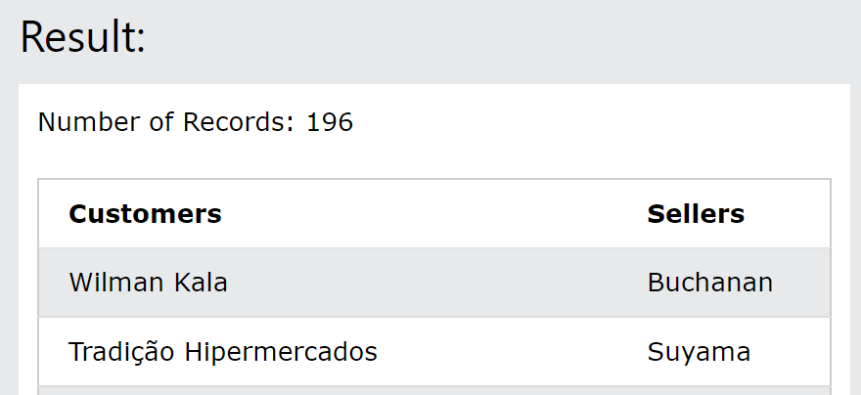

CREATE VIEW [Customers Employees] AS SELECT CustomerName AS [Customers], LastName + FirstName AS [Seller] FROM ((Orders INNER JOIN Customers ON Orders.CustomerID = Customers.CustomerID) INNER JOIN Employees ON Orders.EmployeeID = Employees.EmployeeID);

Q7: Write a query to create a view for those salesmen belongs to the city New York.

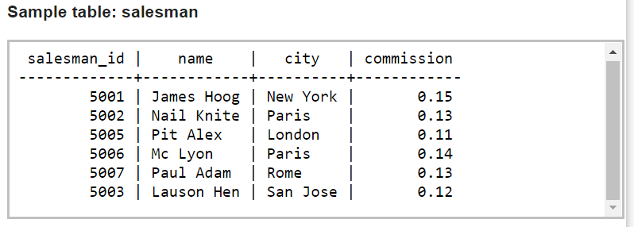

CREATE VIEW [City] AS SELECT * FROM Saleman WHERE city = “New York”;

**Q8:** Write a query to find the salesmen of the city New York who achieved the commission more than 13% with the view you just created in Q7.

CREATE * FROM salesmen WHERE city >13;